For Central Office use only:

Region ___________________

Proposal # ___________________
For Regional Office use only:

Please rate the level of need from
1 (lowest) through 10 (highest)
Rating ________ Initial ________

DEPARTMENT OF PUBLIC SAFETY AND CORRECTIONS – YOUTH SERVICES (YS)
OFFICE OF JUVENILE JUSTICE (OJJ)

ALTERNATIVES TO DETENTION (ATD) FUNDING APPLICATION- FY 2023-2024
PROGRAM INFORMATION

Program: _____________________________
Program Title: ________________________
Amount of Funding: $______________

Federal Tax ID#: _________________

Type of Organization: ______________________

Mailing Address: ______________________
______________________

Physical Address: ____________________
_____________________

- Who is the official authorized to sign contracts for your organization?

Name Title

E-mail Phone

- Who can answer questions about your program? (Only list if different than #1.)

Name Title

E-mail Phone

- Who can answer questions about the budget?

Name Title

E-mail Phone

4. What is the projected total number to be served during the project period?
a) Per diem or monthly rate? ______________ (or attach a fee schedule).

5. What is the total estimated number of days of service?

- How will your program accomplish the following:

- Reduce delinquency and recidivism

- Reduce the level of involvement of youth in the Juvenile Justice System

- Reduce costs

- Teach youth to actively choose alternatives to criminal activity

- Ensure only appropriate youth are admitted to the program, in an effort to avoid “widening the net”

- What are the specific services that will be provided? Answer each of the following questions in 10 sentences or less:

  - What are the specific services that will be provided (i.e. family counseling, group therapy, tutoring, pro-social activities, assessments, etc.)?

  - Who will be providing each of the listed services? Provide the specific job titles (i.e. LPC, teacher, tutor, etc).

Resumes (must be submitted for key personnel) and/or Job Descriptions are required. Job Descriptions should include:

1. Description of work to be performed;
2. Required level of education;
3. Work experience (i.e. how many years in what fields);
4. Any special requirements (i.e. Board certified); and
5. The minimum and maximum salary range.

  - What is the service delivery process? Begin with pre-admission; describe referral, expulsions, program admission, frequency of services, the method of pre/post testing, and aftercare processes. Describe how youth will access services, include transportation.

  - What do you consider a successful completion of the program?

Refer to YS’ Standard Operating Procedures for information regarding educational and experience requirements for key staff at: https://ojj.la.gov/wp-content/uploads/2020/07/A.4.2-a-Standard-Operating-Procedures-for-Contract-Providers-Dec-2019.pdf Who will the program serve:

A. What is the age range of youth to be served? ______________________________

B. What is the gender of youth to be served? _________________________________

- What is the need for program, other possible funding sources and collaborative partnerships in your community? Answer each of the following questions in 10 sentences or less:

  - How does the program address gaps in service needs and are there other programs providing similar services?
________________________________________________________________________________________________________________________________________________________________________________________________________________________________________________________________________________________________________________________________________________________________________________________________________________________________________________________________________________________________________________________________________________________________________________________________________________________________________________________________________________________________________________________________________________________________________________________________________________________________________________________________________________________________________________________________________________________________________________________________________________________

  - What are your current funding sources? Identify amounts of current funding sources. What are possible future funding sources?
________________________________________________________________________________________________________________________________________________________________________________________________________________________________________________________________________________________________________________________________________________________________________________________________________________________________________________________________________________________________________________________________________________________________________________________________________________________________________________________________________________ _ ___

  - What partnerships or collaborations do you have with other agencies and providers in your community?

____________________________________________________________________________________________________________________________________________________________________________________________________________________________________________________________________________________________________________________________________________________________________________________________________________________________________________________________________________________________________________________ ______________________________________________________________________ _______________________________ __________________________________________________

- What are the proposers' qualifications and experience? Answer each of the following questions in 10 sentences or less.

- What experience does proposer have in the provision of the type of program services offered? (This could include previous contracts with YS or other state agencies, previous grants awarded, etc.)

____________________________________________________________________________________________________________________________________________________________________________________________________________________________________________________________________________________________________________________________________________________________________________________________________________________________________________________________________________________________________________________________________________________________________________________________________________________________________________________________________________ __

- What evidence can you provide that demonstrates that your previous services were satisfactory?

____________________________________________________________________________________________________________________________________________________________________________________________________________________________________________________________________________________________________________________________________________________________________________________________________________________________________________________________________________________________________________________________________________________________________________________________________________________________________________________________________________ __

C. Does your organization have the necessary technical qualifications and skills to provide these services? Clearly explain below.
____________________________________________________________________________________________________________________________________________________________________________________________________________________________________________________________________________________________________________________________________________________________________________________________________________________________________________________________________________________________________________________________________________________________________________________________________________________________________________________________________________ __

- Site (Provide site and floor plans if services are not provided to clients in their own homes. If services are to be provided in rental property include an approved lease that includes the use of the property for services proposed.) Answer each of the following questions in 10 sentences or less:

- What is the location of the physical facility where services are provided? Is the site easily accessed by the youth and families? (Address transportation issues)
____________________________________________________________________________________________________________________________________________________________________________________________________________________________________________________________________________________________________________________________________________________________________________________________________________________________________________________________________________________________________________________________________________________________________________________________________________________________________________________________________________ __

- Is there adequate space for the physical needs of the youth for proposed service? Clearly explain below.
______________________________________________________________________________________________________________________________________________________________________________________________________________________________________________________________________________________________________________________________________________________________________________________________________________________________________________________________________________________________________________________________________________________________________________________________ ______________________________________________________________________________ __

- How soon can you begin the provision of services, after contract is approved?

______________________________________________________________________

- Performance Measures:

    - Number of youth served by the program
    - Number and percent of youth who successfully complete the program
    - Number and percent of youth who were referred to court while attending the program
    - Number and percent of youth who report benefiting from the program as evidenced by satisfaction surveys
    - Number and percent of families who report benefiting from the program as evidenced by satisfaction surveys

These performance measures will be reported by the 10th of each month following date of service.

- Outcomes Measures:

      - Number and percent of youth who demonstrate increased knowledge of pro-social behavior/attitudes as evidenced by pre and post testing
      - Number and percent of youth who did not receive a new adjudication while attending the program
      - Number and percent of youth whose charges were dismissed as a result of program completion

The program’s overall performance and outcomes measures will be submitted via monthly reports completed in electronic format provided by OJJ.

_________________________________________________ ________________________
Authorized Individual Signature Date

___________________________________________ ___ ___________________________
Name (please print) Title
PROGRAM BUDGET AND NARRATIVE

PROGRAM BUDGET
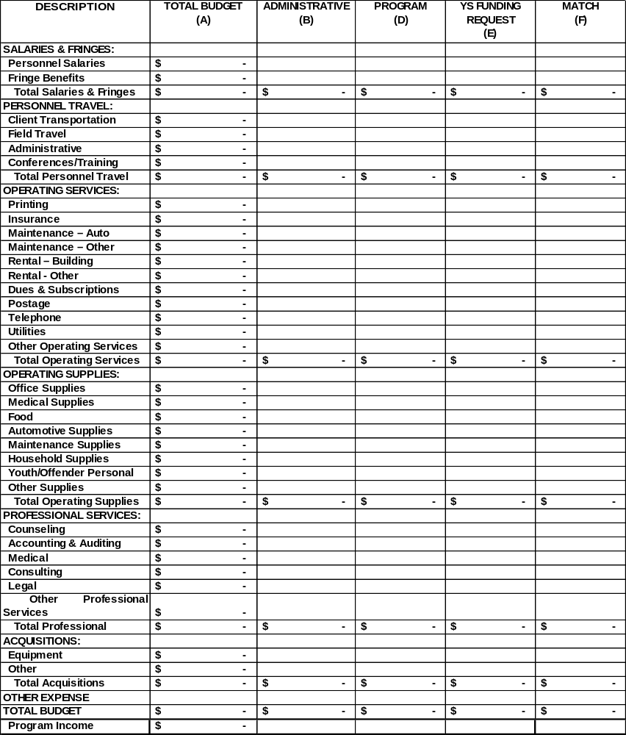

The Program Budget and Budget Narrative should include only those items related to this program. The budget provided must correspond to the period funded. The budget will be used to calculate the per diem and/or rate of reimbursement. The form above is an imbedded Excel worksheet. Double click on it to complete. Subtotals and totals are automatically calculated and protected.

COLUMNS

A Budget: the entire amount allotted to this program regardless of source of funding. This field is automatically calculated.
B Administrative: the expenses associated with the managerial functions of the program. This will not include any expense associated with direct service delivery to youth/families. Typically these expenses will not fluctuate based on the number of youth/families served.
C Programmatic: expenses associated with direct service delivery.
D YS Funding Request: the total amount requested from YS for this program.
E Match: Resources, whether in-kind or cash contributed by the applicant may be used as Match. This amount must equal 25% of the YS Funding Request. This amount may not include state or federal funding or funding used to match another state or federal grant.
F. This field will display the word “ERROR” if the sum of columns D and E do not equal column B, otherwise “OK” will be displayed.

BUDGET NARRATIVE

A FULL Explanation should be provided for each category in the Program Budget.

- On a separate sheet provide information for each category listed on the budget form.

- All expenses must be described in the budget narrative and quantified on the budget form. A full explanation must be given of each category detailing the goods/services used to derive the estimated expenses on the budget form. This explanation must include the item procured, recipient of the item, purpose of the item in further program objectives as well as indication if the item is a one-time expense. (Budget must be inclusive of all income and expenses that will be incurred during the program.)

- Any deviation from the approved budget must have YS written approval prior to incurring the expense. Deviation may require a contract amendment.

- Expenditures not in your approved budget or over your budgeted amount will be disallowed, if prior approval has not been obtained.

- Provide each source and amount of “Match” for this program in your narrative. For example: Entergy utility bill for office space paid by Parish Council at $100.00 X 10 months =$1,000 Match.

- All expenses must be pro-rated for this program. Expenses incurred outside the dates of the contract awarded are not reimbursable.

- All expenses must be reasonable and necessary and may not include expenses incurred outside the start and end dates of the contract or retroactive pay increases.

The following instructions are to be used to determine which expenses to allocate in each category on the budget form and to compose the budget narrative.

SALARIES

- List the name(s), position(s), total salary, percentage of compensation allotted to YS funding and match, and full/part-time status of staff actually working on this program in the narrative. Funds may not be used to supplant positions that are already funded.

- Time and attendance records must be current, maintained for a minimum of 3 years and are subject to audit.

FRINGE BENEFITS

- Provide only the employer’s share for funded salaries.

- Fringe benefits may not exceed 25% of the total salary.

- Fringe benefits may only be paid for staff listed in the above salary section.

- The rate or expense used for calculation must be shown for each type:

  - Social Security (FICA): 6.2%
  - Medicare: 1.45%
  - Health/Life Insurance
  - Workers’ Compensation
  - Unemployment
  - Public/Private Retirement
  - Liability/Malpractice Insurance (if part of an employee benefit package)

TRAVEL/TRAINING

- Travel should indicate the individuals, purpose and itemized listing of travel costs (i.e., destination, mileage rate, meals, registration, etc).

- Travel funded by YS must be in accordance with Division of Administration, Policy and Procedure Memorandum 49. The State Travel Regulations include allowable travel rates of reimbursements and may be accessed at https://www.doa.la.gov/media/n10b4oil/ppm49-2022-07-01.pdf

3. Only actual travel expenses are reimbursable. Expenses for each event must be documented on a separate FACS BA-12 Travel Expense Account form (see https: https://www.doa.la.gov/doa/ost/forms/ )

OPERATING SERVICES

- Maintenance and/or rental agreements should individually list the items and period covered.

- The expense associated with services needed to operate the program. This may include, but is not limited to the following:

  - Telephone/Cellular/Internet service.
  - Advertising
  - Rent
  - Insurance
  - Subscriptions
  - Maintenance/Service Agreement
  - Postage
  - Utilities
  - Laboratory
  - Repairs
  - Printing*

*All printed material must bear a prominent statement: “This public document was printed at a total expense of $_____. (Number copies were published in this (Number) printing at an expense of $______. The total expense of all printing of this document, including reprints, is $______. This document was produced by (Printer’s Name) for the Office of Youth Development, 7919 Independence Blvd., Baton Rouge, LA 70806. It was printed in accordance with standards for printing by state agencies established pursuant to R.S. 43:31.”

OPERATING SUPPLIES

- Supply items are consumable and have a life expectancy less than one year. This may include but is not limited to the following items:

  - Office materials
  - Food/Refreshments
  - Medical/Dental/Pharmaceutical items
  - Clothing
  - Education/Recreational materials
  - Maintenance items
  - Automotive materials

PROFESSIONAL SERVICES

- Professional Services may include legal, consulting, counseling services procured from contractors, or accounting.

- All professional services should list the service provider name and title, description of the services provided, rate of payment and the annual dollar amount of each contract/agreement.

ACQUISITIONS

A listing of the acquisitions/equipment should include a description of each item, purpose within the program and its acquisition cost.

OTHER

Other expenses should list the type, purpose, method of computation, quantity, etc.

Additional information regarding budget categories may be found at:
https://www.doa.la.gov/media/uphhkha2/chap13.pdf

